**Mini kube Installation**

**1.**Lauch ec2 instance using ubuntu os and take t2 medium

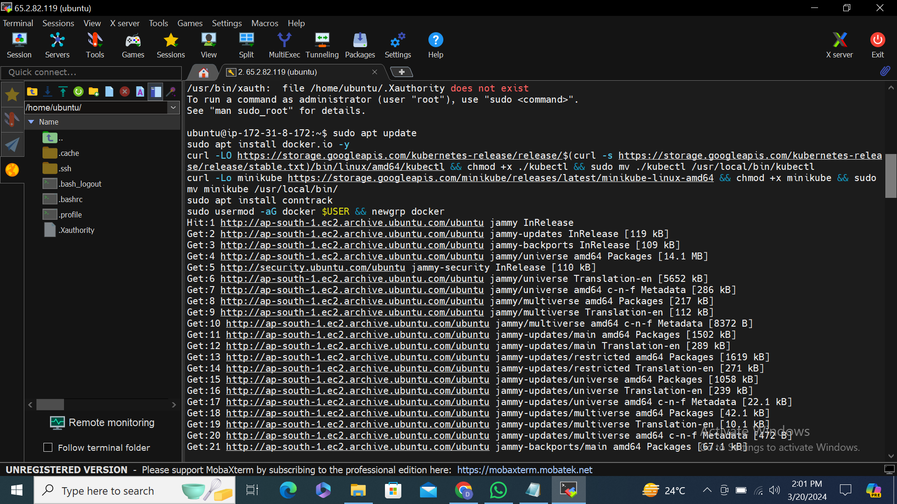

2.

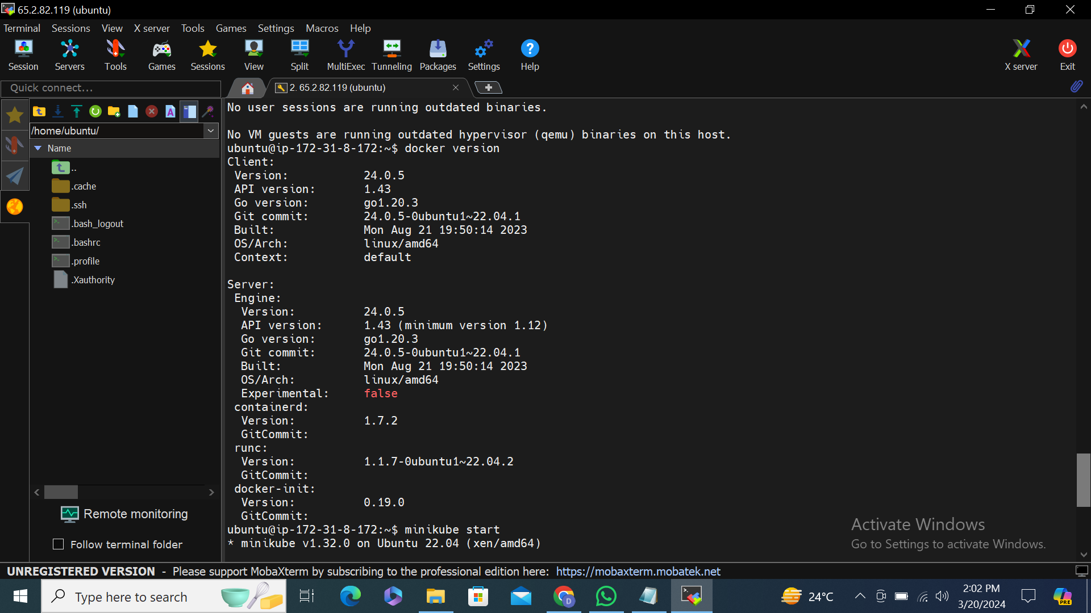

3.start minikube and search version

